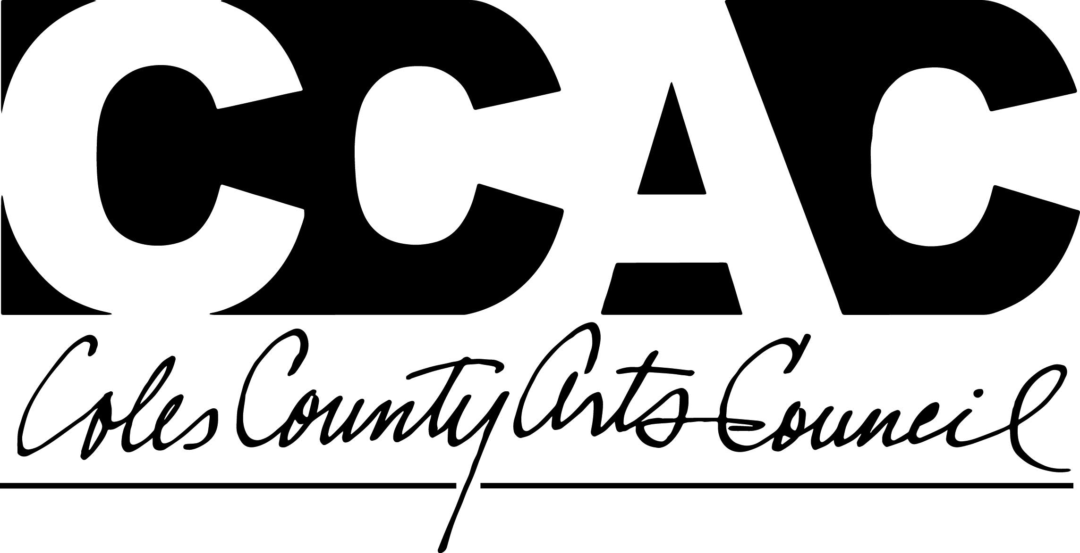 Scholarship-Visual Arts
SPONSORED BY THE COLES COUNTY ARTS COUNCIL

TO ATTEND: SUMMER ART SCHOOL FOR HIGH SCHOOL STUDENTS
On the campus of EASTERN ILLINOIS UNIVERSITY
June 23-29
*Meet other passionate young artists
*Spend a week immersed in the Arts
*Experience campus life in EIU Residence Halls
Classes include: Drawing
Painting
Jewelry/Metals
Ceramics (Raku)

SCHOLARSHIP DETAILS:
One (1) full scholarship to attend the 2019 EIU Summer Art School will be awarded by the Coles County Arts Council (CCAC). High school students attending Charleston, Mattoon, or Oakland High Schools may apply. This includes students who will be graduating from middle school or from high school in May of 2019.

Selection is competitive and based on entering into the Mattoon Arts Council (MAC) Spring Art Show and a Personal Statement. Submit both your Application, Personal Statement and release to CCAC. Send your Art Show application to MAC. Scholarship will be paid directly to EIU on behalf of the recipient.

Information and application for the MAC Spring Art Show may be found at: https://www.mattoonartscouncil.org/ Click on the link for the “Student” form, and contact MAC for any questions regarding their expectations and requirements for submitting work: arts@mattoonillinois.org Rules and details can be found on their Facebook page, as well.

Please note: MAC allows each person to enter up to two pieces into the art show. Scholarship winner will be selected based on judges’ favorite piece. So the more that you enter, the greater your chances! MAC will also be awarding their own scholarships and prizes.

This show is for 2D work. No kits, copies of copyrighted images, or “paint party” paintings will be considered. Original work completed by the student as a classroom assignment is acceptable.

Arts Scholarship
c/o Coles County Arts Council
PO Box 163
Charleston, IL 61920

SUBMISSION DEADLINE: Should be postmarked no later than March 8th. See attachment for timeline of events.

Winner we be announced by the end of March.

Spring Art Show runs from March 29-31

CCAC Scholarship Application-Visual Arts

(PLEASE PRINT OR TYPE)

Name: ____________________________________________________________________________________________________________________

Home Address: __________________________________________________________________________________________________________

Phone: ________________________________________________ Email: ___________________________________________________________

Grade you are enrolled in Spring 2019: _______________________________________________________________________________

School: _____________________________________________________________________________________________________________________

Personal Statement

Please attach to your Application a one paragraph, typed, Personal Statement describing the role(s) and significance that visual arts play in your life, and why you think attending art camp would benefit you.

WAIVER

I give the Coles County Arts Council permission to post to the CCAC website images of me, and of my artwork submitted as consideration for the 2019 Visual Art Scholarship to attend EIU Summer Art School for High School Students.

Name (print) ___________________________________________________________________

Date: _______________________________

Signature: ___________________________________________________________________

Note, if applicant is under the age of 18 at the time of application, the applicant’s parent or legal guardian must also sign this form:

Name (print): ___________________________________________________________________________

Relation to Applicant: ________________________________________________________ (Please Print)

Signature of Parent or Guardian: ________________________________________________________

Date: ___________________________________
Deadlines

March 8: Application, Personal Statement, and Waiver sent to CCAC

Also

Intent to Exhibit due to MAC (Fill out the submission form for “student” on their website)

March 17: Optional hanging workshop (to learn how to properly hang your work) 2-4pm
Sign up list will be available after the Intent to Exhibit form is completed.

March 17-21: Deliver artwork (must be framed and ready to hang) to Office of Arts and Tourism at the Mattoon Train Depot

March 29-31: Art Show at Mattoon Train Show

March 31-April 1: Pick up Art Work. Select time on the MAC entry form.

If you win the CCAC scholarship, it is your responsibility to apply to the EIU Summer Arts Camp, and to inform the Visual Arts chair, Heather Siegel (hlcuria@eiu.edu), when you have applied. The check will then be mailed to EIU on your behalf. Mattoon Arts Council will have their own processes and policies for their own awards.

